20.59: a)
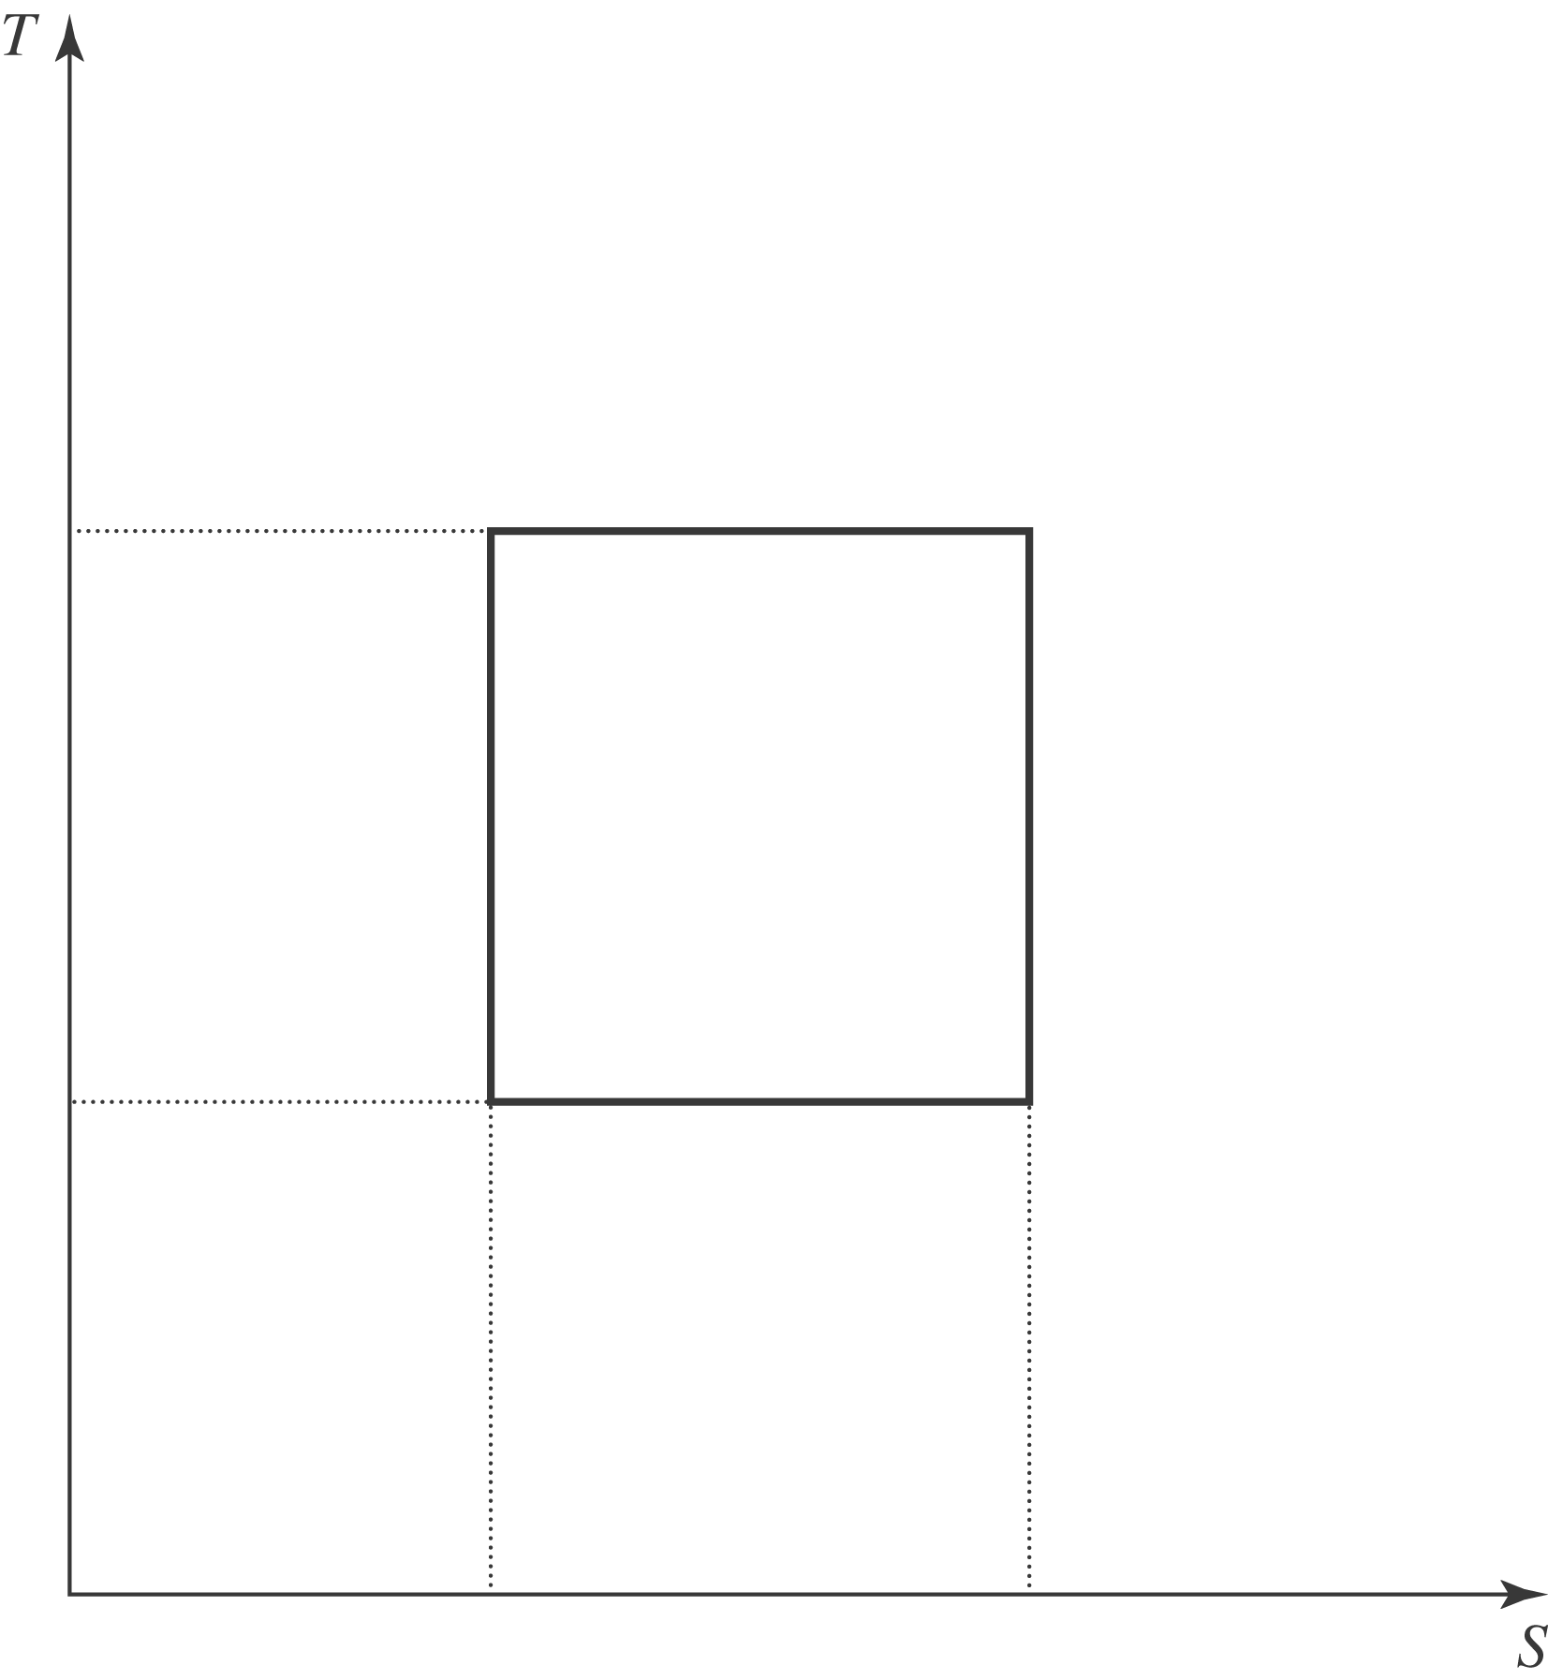

b) From Eq. (20.17), 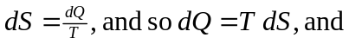
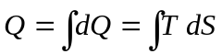
which is the area under the curve in the TS plane. c)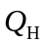 is the area under the rectangle bounded by the horizontal part of the rectangle at 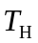and the verticals. 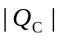 is the area bounded by the horizontal part of the rectangle at 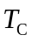and the verticals. The net work is then 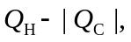 the area bounded by the rectangle that represents the process. The ratio of the areas is the ratio of the lengths of the vertical sides of the respective rectangles, and the efficiency is 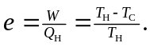 d) As explained in problem 20.49, the substance that mediates the heat exchange during the isochoric expansion and compression does not leave the system, and the diagram is the same as in part (a). As found in that problem, the ideal efficiency is the same as for a Carnot-cycle engine.

